- Save a copy of the workbook on your computer for your personal use.

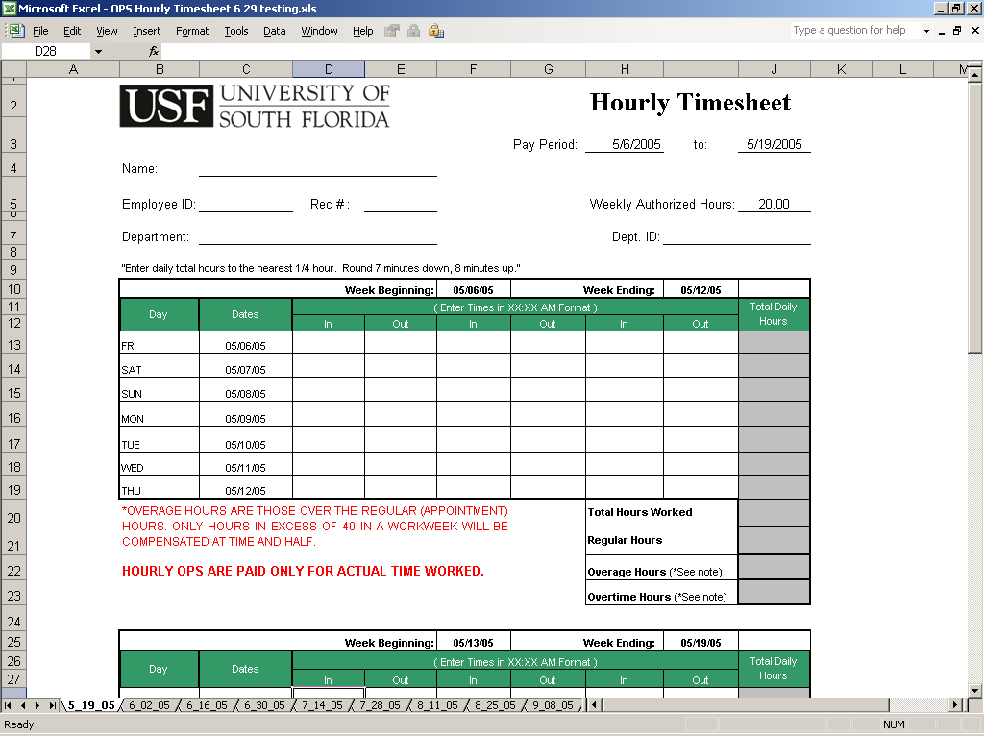
Select Tab
Verify Pay Period

- The Hourly Timesheet is an Excel-based file in a workbook format. A workbook is a collection of worksheets for every biweekly pay period in the current year. When you open the workbook (file), tabs will appear along the lower edge of the screen. Each tab corresponds to a specific biweekly pay period (e.g., 1_13_2005). Each tab identifies the pay period ending on the date of the tab. The tab labeled “1_13_2005” is for the timesheet of the pay period from December 31, 2004 to January 13, 2005. To scroll through the tabs, use the arrows on the lower left of the screen. To select a particular timesheet, place the cursor on the tab and click the mouse.

- The timesheets in the workbook are now ready to be filled out. Select a particular sheet by scrolling through the tab names at the bottom of the screen and then clicking on the tab for a particular pay period. When you open that timesheet, confirm that it is the sheet you meant to select by looking at the “Pay Period: ___ to: ____” dates on the upper right hand corner of the sheet.

- Enter the identifying information at the top of the timesheet including:

- Name
- Employee ID #
- Rec #
- Weekly authorized hours
- Department
- Department ID#

The information that you fill out on the top will be transferred to all of the timesheets in the workbook, so you will not need to enter this information again unless your information changes during the year.

- DO NOT ENTER ANY NUMBERS into the cells along the “Total Daily Hours” column. These are calculated automatically from the “In” and “Out” times entered each day and the “Weekly Authorized Hours” entered at the top of the sheet.

- The “WORK TIME CALCULATOR” determines hours worked as follows:

The Hourly Timesheet in Excel calculates total daily hours based on the “In” and “Out” times that are entered for each day. In order for this calculation to work properly, the time entries have two important features:

- Format – The proper format for a time entry is XX:XX AM. For the purposes of this format, 8:00 am is “Eight, colon, zero, zero, space, am” The space after the two zeros is a critical part of the entry.

- Rounding – The times entered into the “In” and “Out” columns should be rounded to the nearest quarter hour. For example, if you arrive at work at 7:59 am, this should be entered as 8:00 am. If you arrive at work at 8:07 am, this should be entered as 8:00 am. If you arrive at work at 8:08 am, this should be entered as 8:15 am “Eight, colon, one, five, space, am”. Remember to round 7 minutes down and 8 minutes up.

- The Overage And Overtime Hours Calculator determines those hours as follows:

The Hourly Timesheet in Excel automatically totals the daily hours worked into a weekly total. These work hours are then automatically assigned to “Regular Hours”, “Overage hours”, and “Overtime Hours” as appropriate. The “Weekly Authorized Hours” entered at the top of the sheet are used as the upper limit to “Regular Hours”. Any hours worked in excess of the weekly authorized hours are assigned as “Overage Hours”. These hours are not necessarily paid at time and one half. To get paid for time and one half, an employee must work over 40 hours in a workweek. Thus, an employee who is appointed for 35 hours, and works 42 hours, will have 7 “Overage Hours” on the timesheet. Five of these hours will be paid at straight time. Two hours are paid at time and one half, and this figure appears as “Overtime Hours”.

- Printing And Signing The Timesheet

When you have completed the timesheet for a particular pay period, print that sheet. It is then signed by the employee and the employee’s supervisor.

