**Main Signature Line in Microsoft Office**

The easiest way would be to copy/paste into your signature line and enter in your information where necessary.

1. Open
2. Click on new email
3. Click on signature
4. Click on signatures
5. Click on New
6. Save name as “your name”
7. Copy/paste template
8. Save

**Reply Message**

1. Create New
2. Save name as “Reply”
3. Copy/paste Template
4. Save

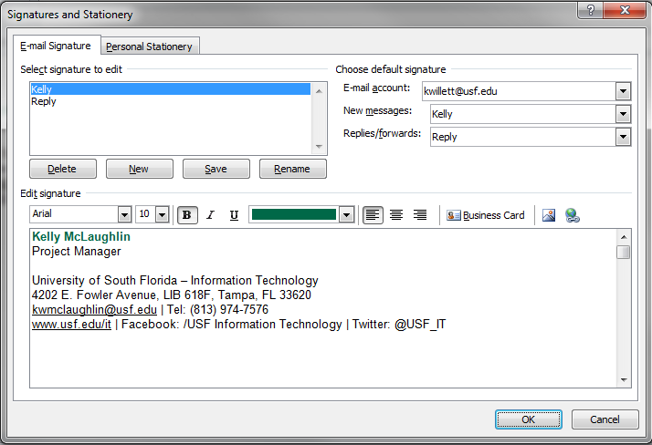Make sure you change default settings on the right-hand side of the Signature Line Options. See below.

**Font Style:**

Text: Arial  
Font Size: 10  
Font Size Name 10 Bold  
Name Color USF Green/ RGB: R- 0 G- 104 B- 72 Hex: #006848  
 Marine Science Blue/RGB – R- 0 G- 100 B- 132 Hex: #006484

Color:

1. Highlight your name
2. Click on the Color Box,
3. Click on More Colors
4. Color Model should be set to RGB,
5. Enter numbers R – 0 ; G 104; B – 72
6. Click OK

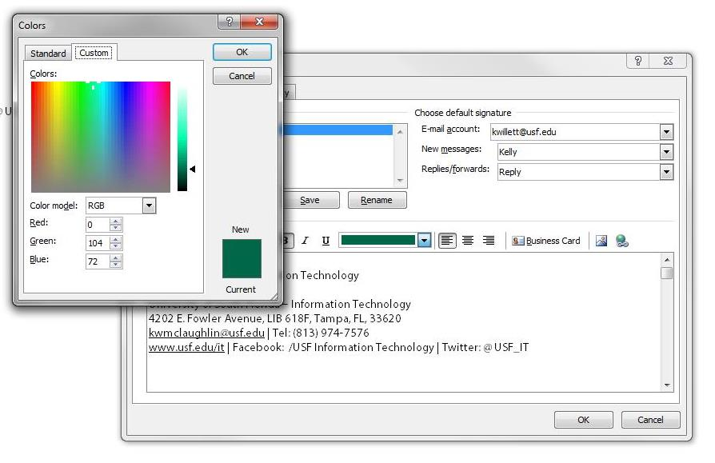

**Microsoft Outlook Signature Line**

Template:

**Your Name Here**Title Here

University of South Florida – **College of Marine Science**  
140 7th Ave S, Office Number, St Petersburg, FL 33701  
[youremail@usf.edu](mailto:youremail@usf.edu) | Tel: (727) 553-1234  
[www.marine.usf.edu](http://www.marine.usf.edu) | Facebook: /[USFMarineScience](https://www.facebook.com/USFMarineScience) | Twitter: [@USFCMS](https://twitter.com/USFCMS)

**Reply Signature Lines**

Template:

**Your Name Here**Title Here | **USF College of Marine Science**  
[youremail@usf.edu](mailto:youremail@usf.edu) | Tel: (727) 553-1234

**Webmail (OWA)**

1. Open Tools Option (next to person icon) on the top right hand side of computer
2. Click on Settings (left hand side)
3. Type in or copy and paste the following Signature line

**OWA Signature Lines**

Template:

**Your Name Here**Title Here | **USF College of Marine Science**  
[youremail@usf.edu](mailto:youremail@usf.edu) | Tel: (727) 553-1234

Thunderbird

1. Open Tools Option
2. Click on Account Settings
3. Click on the Account Name you want to edit the signature for (typically [yourname@usf.edu](mailto:yourname@usf.edu)
4. Check the box “Use HTML”
5. Customise with your info and paste the following in the Signatue Text box  
   (the red colors are the text you have to replace, red won’t show in Thunderbird)
6. Click OK to close

</br></br>  
<div style="font-family:Arial, Helvetica, sans-serif;font-size:10pt;"><hr>  
<span style="color:#006848"><b>**Your Name Here**</b></span></br>  
Title Here</br></br>  
<span style="color:#006848">University of South Florida</span> &#8211; <span style="color:#006484"><b>College of Marine Science</b></span><br>  
140 7<sup>th</sup> Ave S, Office Number, St Petersburg, FL 33701<br>  
<a href="mailto:youremail@usf.edu"><span style="color: blue;"> youremail @usf.edu</span></a> | Tel: (727) 553-1234<br>  
<a href="http://www.marine.usf.edu"><span style="color:blue">www.marine.usf.edu</span></a> |   
Facebook:&nbsp; <a href=”https://www.facebook.com/USFMarineScience”>/USFMarineScience</a> |   
Twitter: <a href=”https://twitter.com/USFCMS”>@USFCMS</a>  
</span>  
<div>