- Save a copy of the workbook on your computer for your use.
- The USPS Timesheet is an Excel-based file in a workbook format. A workbook is a collection of worksheets for every biweekly pay period in the current year. When you open the workbook (file), tabs will appear along the lower edge of the screen. Each tab corresponds to a specific biweekly pay period (e.g., 1_13_2005). Each tab identifies the pay period ending on the date of the tab. The tab labeled “1_13_2005” is for the timesheet of the pay period from December 31, 2004 to January 13, 2005. To scroll through the tabs, use the arrows on the lower left of the screen. To select a particular timesheet, place the cursor on the tab and click the mouse.
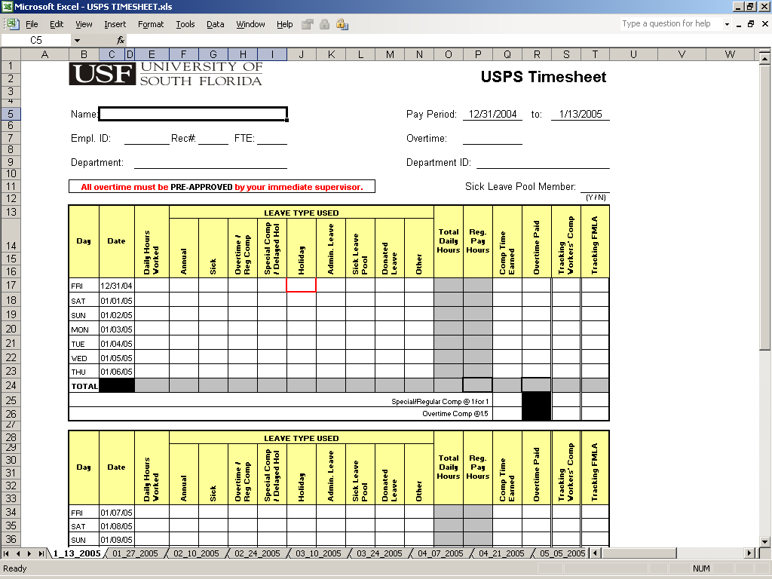
Pay Periods
- Scroll through the tab names at the bottom of the screen to select a particular timesheet. Place the cursor on the tab and click the mouse. When you open that timesheet, confirm that it is the sheet you meant to select by looking at the “Pay Period: ___ to: ____” dates on the upper right hand corner of the sheet.
Select Tab
- The first time you use the timesheet, click on the tab for the correct pay period, then enter the identifying information at the top of the timesheet including:
- Name
- Employee ID #
- Rec #
- FTE
- Select Overtime: Exempt or Non Exempt
- Department
- Department ID#
- Select a “Y” or “N” for Sick Leave Pool membership status
This information will be transferred to all of the timesheets in the workbook, so you will not need to enter this information again unless it changes during the year. Your supervisor can give you any information you don’t have.
- The hours worked should be filled out at this time. Fill in your “Daily Hours Worked” through the end of the first work week, then add any “Holiday” hours earned.
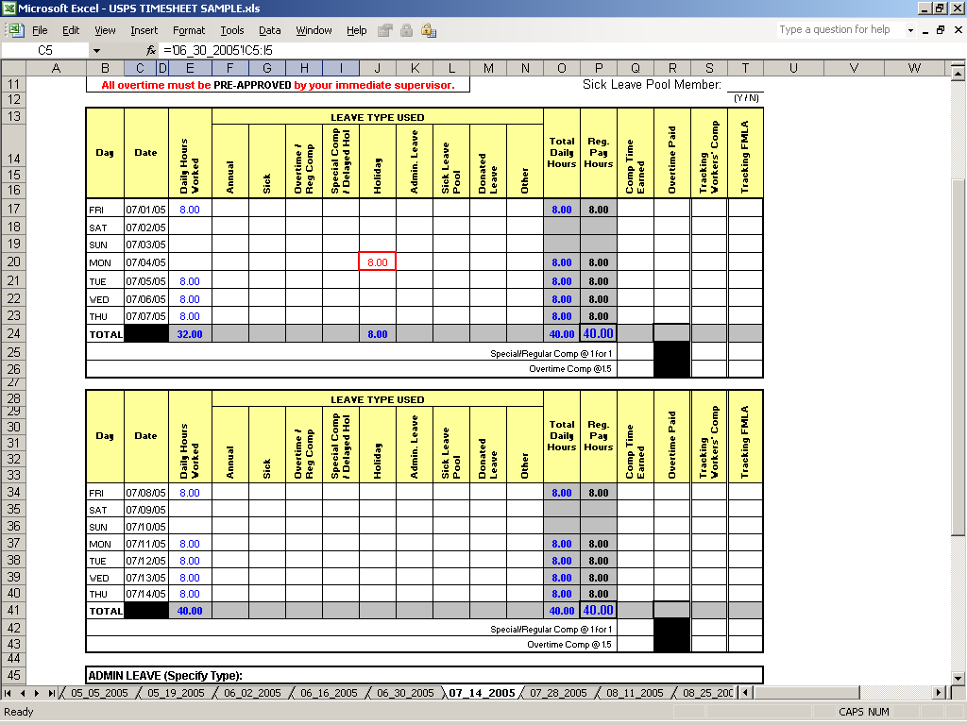
If the total of your “Daily Hours Worked” plus “Holiday” hours is less then 40 hours, use the appropriate type of leave to bring your “Total Daily Hours” to 40 hours. Leave should be entered into the appropriate column as “Annual”, “Sick”, etc.
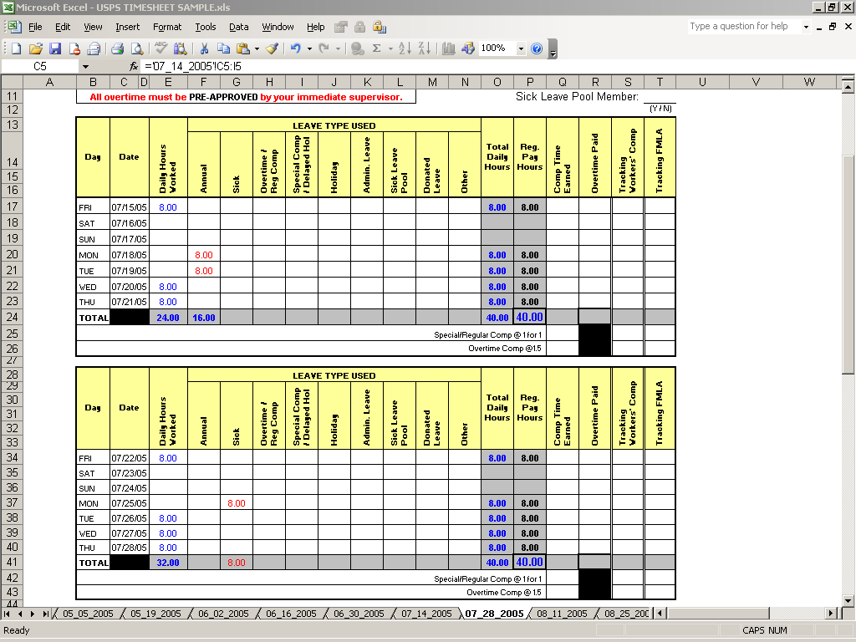
- You cannot enter numbers into the cells along the “TOTAL” row, the “Total Daily Hours” column, the “Regular Pay Hours” column and the “Comp Time Earned”. These are calculated automatically from the work hours, leave hours, comp time earned and overtime that are entered each day.
- After you have finished entering the hours worked and the leave used for a week, notice that the figure for the TOTAL row in the “Total Daily Hours” reports the sum of all your work and leave time. Up to 40 hours of this time appears as regular pay hours and the rest as comp time earned. If you used leave, you cannot have more than 40 hours in the “Total Daily Hours” column.
- If you selected “Exempt” in the Overtime field, Excel will calculate comp time at 1 for 1.
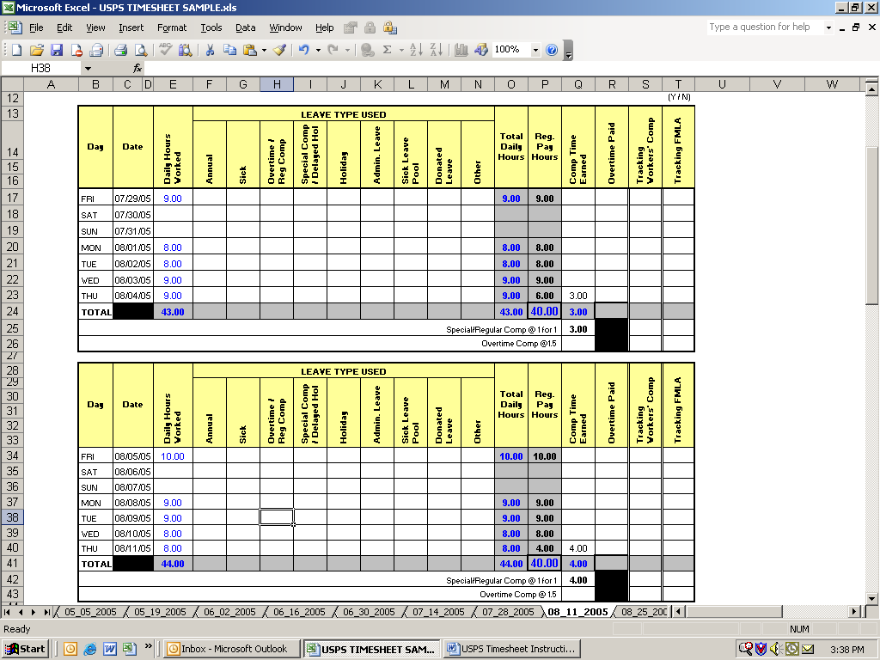
Comp Time is automatically calculated

- If you selected “Non Exempt” in the Overtime field, Excel will automatically calculate the overtime comp time at 1.5. In order for comp time to be earned at time and one half (1.5) rate, an employee in a non-exempt status must actually work more than 40 hours in the workweek. For example, if you actually worked 43 hours in workweek 1, then you have earned comp time at the 1.5 rate resulting in 3 hours of “Comp Time Earned”. The “TOTAL” line under “Comp Time Earned” will be 3. The “Overtime Comp @ 1.5” line, will show 1.5 times this 3 hour total (4.5 hours). This is the amount of comp time actually earned.

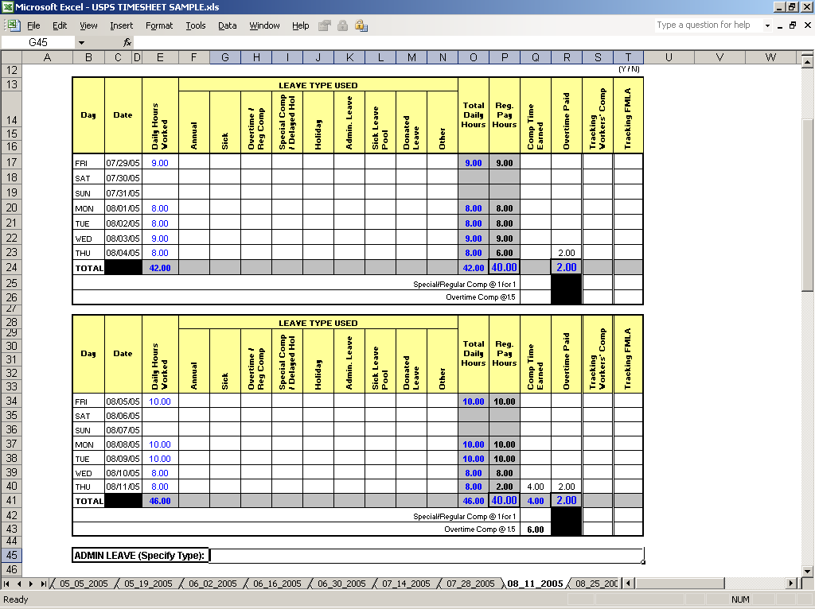

- If a holiday falls on one of your regularly scheduled days off or if you work as essential personnel during an emergency closing, please see your Attendance and Leave Coordinator about proper credit for comp time.

- If you are a Non Exempt employee who has worked over 40 hours and your supervisor has approved the earning of overtime pay, then these hours may be paid overtime. If you actually worked 42 hours, then 2 hours should be entered into the “Overtime Paid” column on the last day worked. Entering the 2 hours of overtime paid will automatically adjust the comp time earned and the “Regular Pay Hours”.
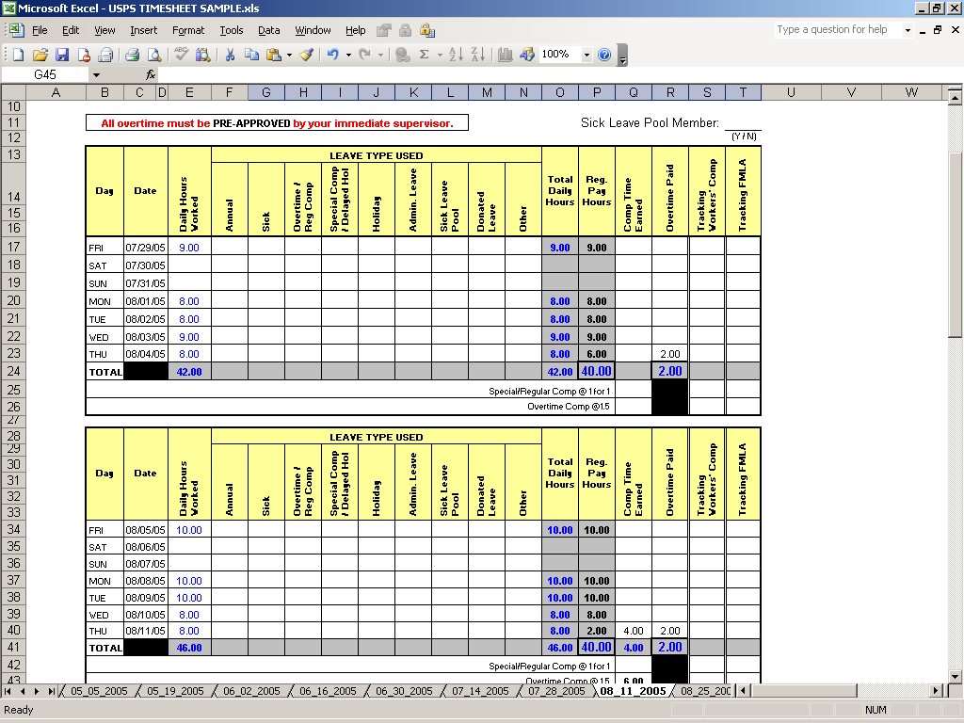
Only 2 Hours of Overtime were authorized- the rest was earned as comp

If you have any questions about how the formula assigns your comp time, please see your Attendance and Leave coordinator.
- When you have completed the timesheet for a particular pay period, print that sheet. This sheet is then signed by the employee and the employee’s supervisor.

