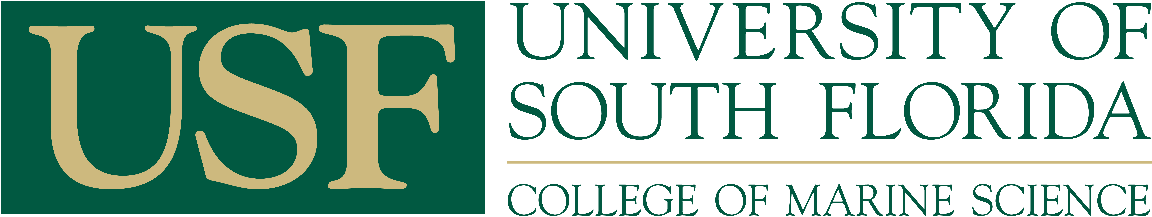

ADVISORY COMMITTEE APPOINTMENT FORM

Please type or print all information, except where noted for signature. Return completed forms to the Academic Affairs Office: MSL 210C

PART I. STUDENT AND DEGREE INFORMATION
Name |  | USF ID# | U
Street Address |  | City, State, Zip
E-mail Address |  | Phone
College | Marine Science | Department  (abbreviate) | Marine Science
Graduate Program | Marine Science | Department  Mail Code | MSL 119
Program Start Date |  | Degree Sought

PART II. COMMITTEE INFORMATION

Masters Committee Members: Two committee members are required from CMS (including one courtesy professor). The third member can be from outside of CMS in an area related to the research.

Doctoral Committee Members: Five committee members are required: Committee consists of five members, at least four of whom must come from CMS (including one courtesy professor). The fifth member must be from outside of CMS. Additional members can be added for additional expertise.

Non- USF Faculty: CV’s are required for all non USF Faculty – please provide electronic copies or attach physical copies: sfrancis1@usf.edu

 | Full Name/  Email Address | Signature of Approval  All members must sign for themselves.  Faxed signatures are accepted. | Dept.  (abbreviate) | Date Signed
Major Professor*  Co-Major Professor* | Email:
Co-Major Professor*  Member | Email:
Member | Email:
Member | Email:
Member | Email:
Member | Email:
Member | Email:

PART III. APPROVALS

 | Full Name | Signature of Approval | Date Signed
Program Director/  Dept. Chairperson | Dr. David Naar
College Dean/  Associate Dean | Dr. David Naar

