
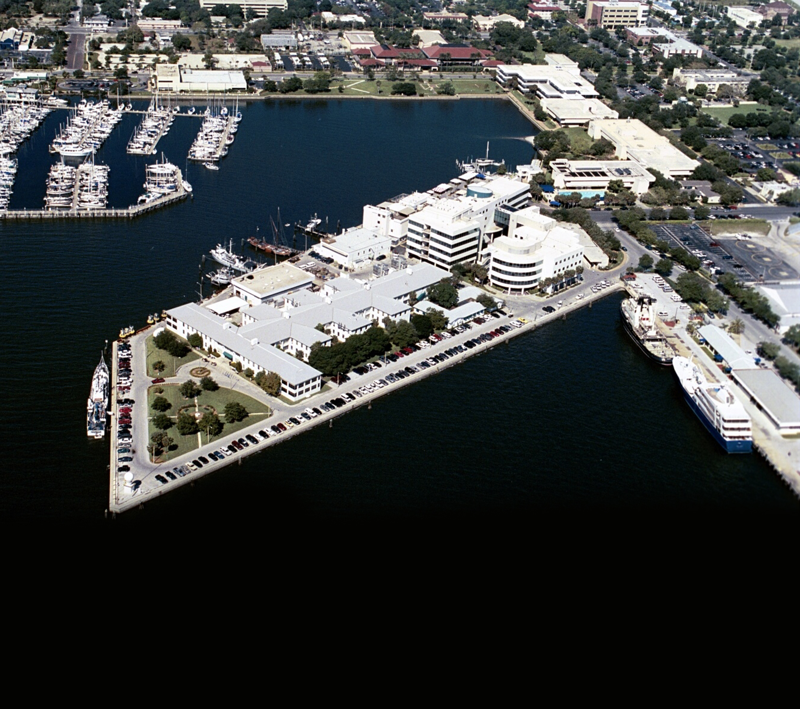
Marine Science Majors
(CRN 56110) Register using OASIS
Other USF Majors
Request Permit from:
Dr. First Last: email@marine.usf.edu
(Include: 1.name, 2.USF ID number,
3. student level 4. Major Program

Not a USF Student?
Become a Non-Degree student and
request a permit. ($30 application fee)
For details, visit:
http://www.usf.edu/Admission/non-degree-seeking.asp

Deadlines:
Register by: August 20, 2010

Enter Your
Course Title
Here

COLLEGE OF
MARINE SCIENCE

Fall 2010 Course
(crn: 12345)

Aug 23 – Dec 10
USF St Petersburg Campus
DAV Bldg, Room 246
Tues / Thur
10:00 am – 11:55 am
ABOUT THE COURSE
Enter your course details here…This course is an introduction to quantitative fish population dynamics. The course is intended not only to present the theoretical elements but also to guide participants on how to put theory into practice through case studies and hands-on exercises on the computer. Specific objectives include understanding the role of population dynamics in fisheries science, gaining familiarity with conventional population dynamics models, and learning about basic model building and parameter estimation. In addition, students will learn how population dynamics is incorporated into the process of fisheries management. Class discussions will focus on current methods and also on possible ways to improve population dynamics models in the future
How to Register

