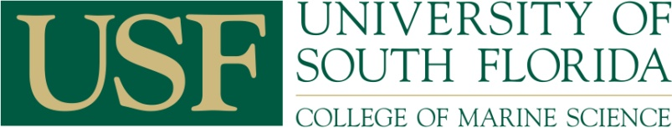
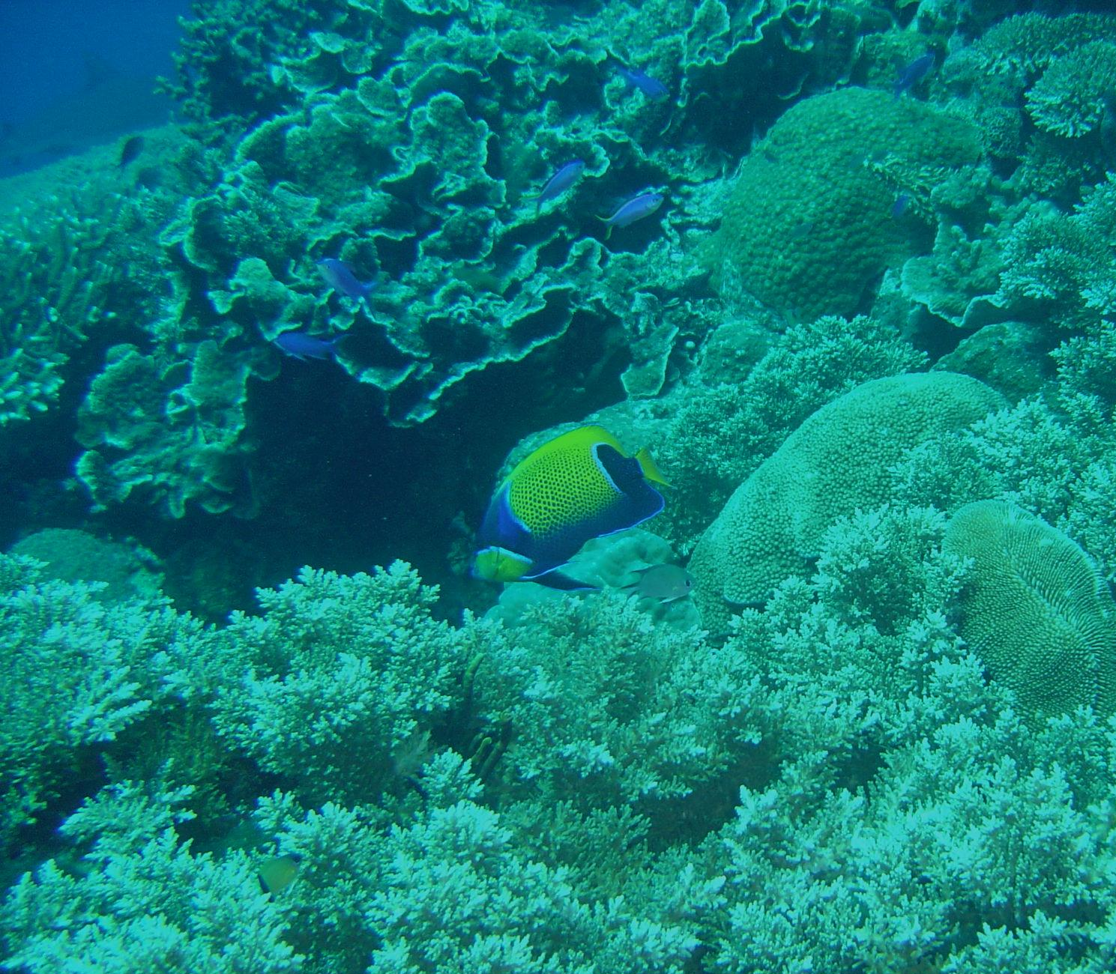
Biology and ESP Majors
Register using OASIS
Other USF Majors
Request Permit from:
Dr. Pamela Hallock Muller: pmuller@.usf.edu
(Include: 1.name, 2.USF ID number,
3. student level 4. Major Program

Not a USF Student?
Become a Non-Degree student and
request a permit. ($30 application fee)
For details, visit:
http://www.usf.edu/Admission/non-degree-seeking.asp

Deadlines:
Register by: August 24, 2012

Coral Biology & Reef Ecology
OCE 4930 (614)

COLLEGE OF
MARINE SCIENCE

Fall 2012 Course
(crn: 92843)

Aug 27 – Dec 7
USF St Petersburg Campus
DAV 245
Mon/Wed
3:00 pm – 4:20 pm
ABOUT THE COURSE
Coral reefs worldwide are threatened by human activities ranging from local boat groundings to global change processes. The objectives of this course are to introduce students to coral biology, to the ecology of coral reefs including what coral reefs are, the kinds of organisms that make up reef communities, environmental conditions required for reefs to thrive, a brief history of reefs through time, the importance of coral reefs to humans and how human activities are affecting coral reefs.

Prerequisites: BSC 2010, 2011, CHEM 2045, 2046; or equivalent

How to Register

